Installation Tomcat Server

Basic commands :
$ sudo apt update
$ sudo apt install openjdk-11-jre -- install JAVA 11
$ java -version
$ wget https://dlcdn.apache.org/tomcat/tomcat-9/v9.0.76/bin/apache-tomcat-9.0.76.tar.gz
$ tar -xvf apache-tomcat-10.1.9.tar.gz -- Extract tar file using tar command
$ cd apache-tomcat-10.1.9
We can see Apache Tomcat files using ls command like below
➔ To deploy applications into Tomcat server we will use Host Manager
➔ By default, the Host Manager is only accessible from a browser running on the same machine as Tomcat. If you wish to modify this restriction, you'll need to edit the Host Manager's context.xml file.
File Location: /webapps/manager/META-INF/context.xml
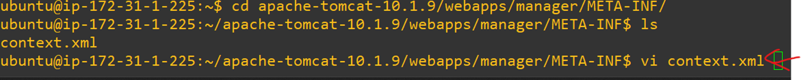
In Manager context.xml file, change section like below (allow attribute value changed)
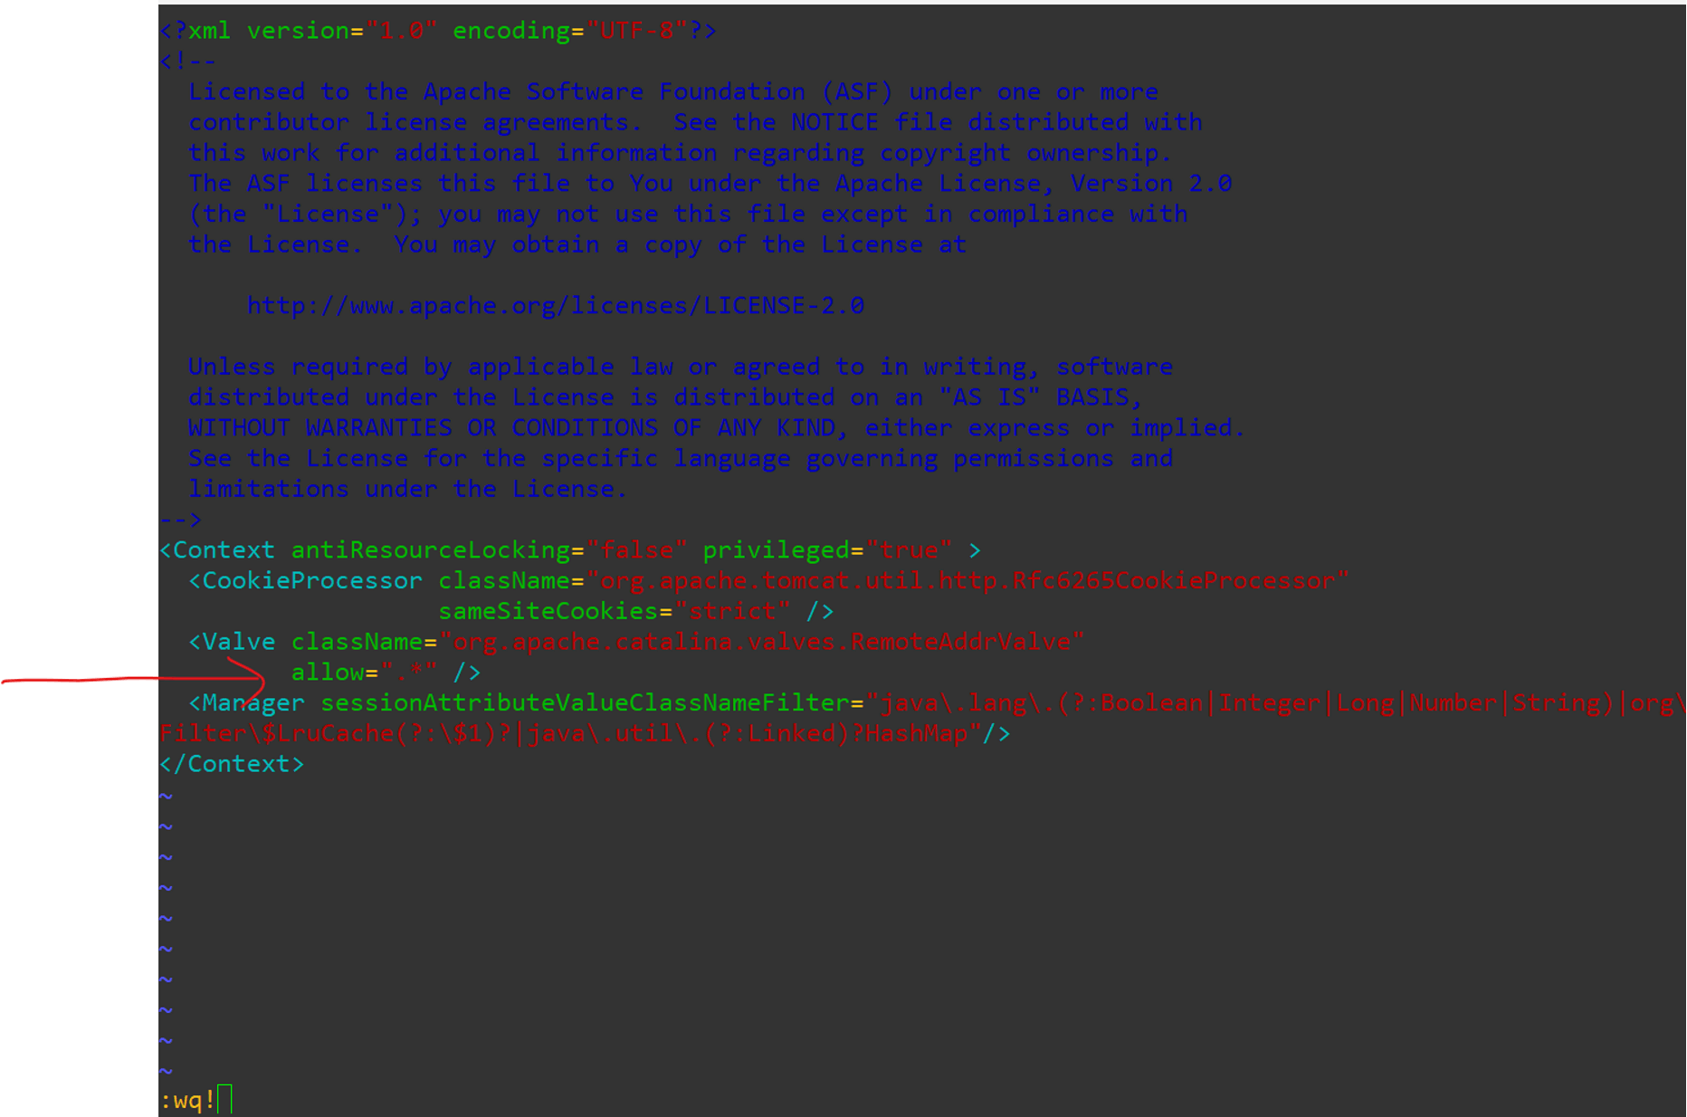
Adding Users in Tomcat Server
➔ We need to add users in tomcat server to perform admin activities
File Location: /conf/tomact-users.xml
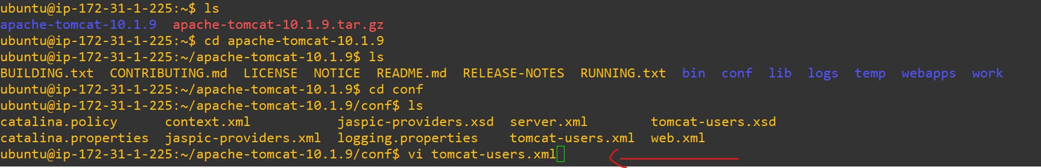
➔ Add below Roles and Users in tomcat-users.xml file
<role rolename="manager-gui" />
<role rolename="manager-script" />
<role rolename="admin-gui" />
<user username="tomcat" password="tomcat" roles="manager-gui" />
<user username="admin" password="admin" roles="manager-gui,admin-gui,manager-script"/>
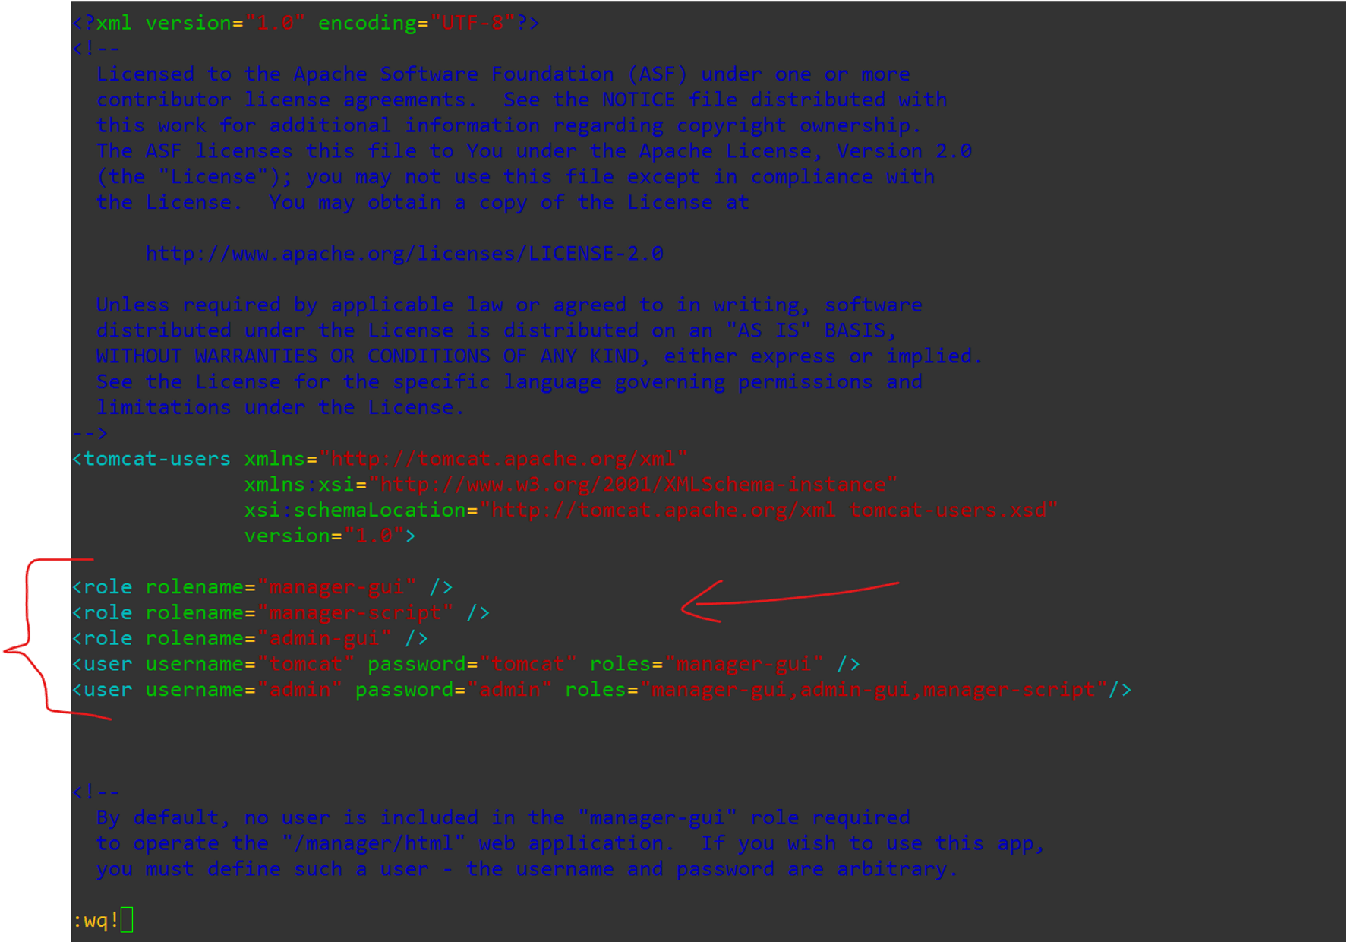
➔ After adding users, go to bin directory and start the Tomcat server
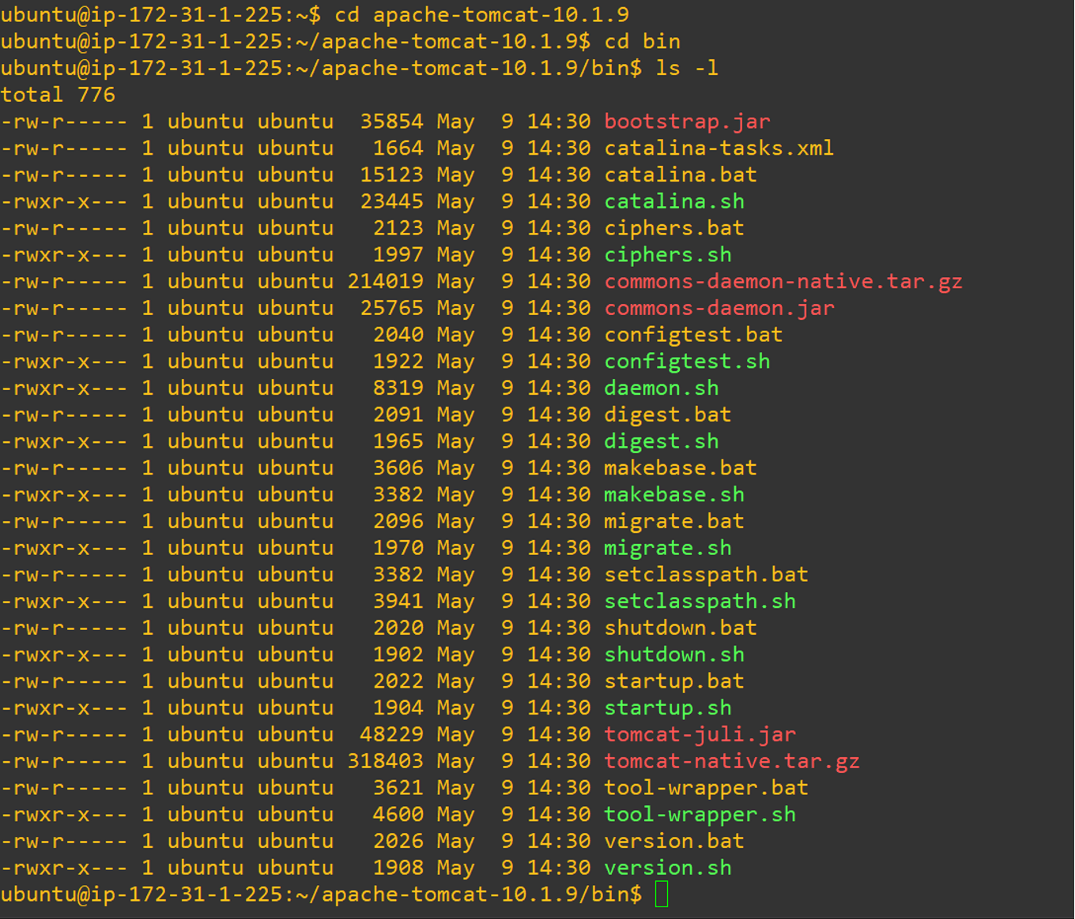
Start the tomcat server using ‘sh startup.sh’ command
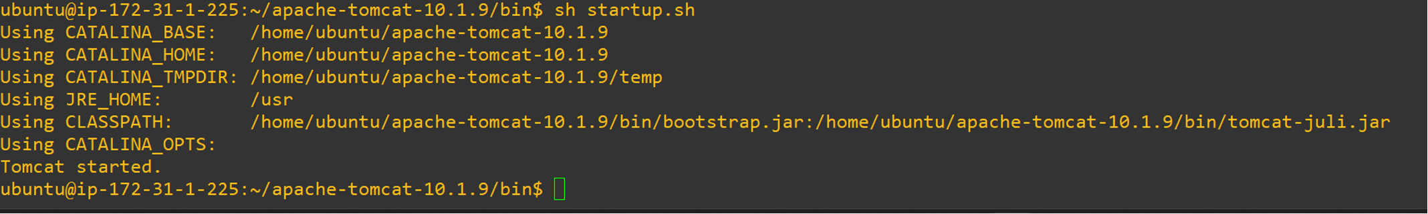
Once Tomcat Server started, we can access Tomcat Server admin console using EC2 Instance Public IP :
Note : Make 8080 port number is enabled in your EC2 Instance Security Group.
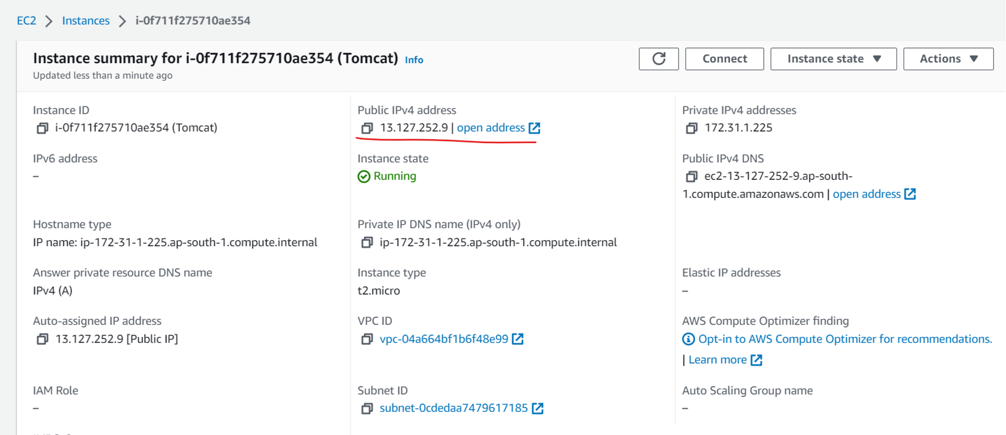
We can access Tomcat Server in our Browser like below -
Open Manager App
